BE SURE TO INCLUDE YOUR PERSONAL AFFILIATE LINK FOR TRACKING.
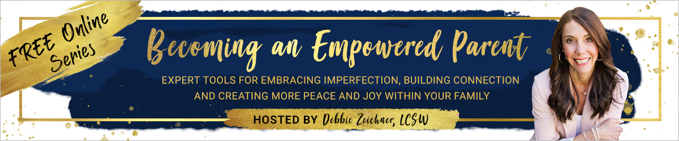
Newsletter Blurb:
If you ever struggle with the everyday challenges of raising your kids, find yourself caught in frequent power struggles, wish your kids would “just listen,” or experience feelings of guilt, shame, overwhelm or frustration, you are not alone!
Isn’t it amazing that the most important job in the world doesn’t come with a guide or instruction manual? My friend/colleague and Parent Coach, Debbie Zeichner, is on a mission to change this. The best part? It’s completely FREE!
Debbie has put together a powerful online interview series, Becoming an Empowered Parent: Expert Tools for Embracing Imperfection, Building Connection and Creating More Peace and Joy Within Your Family. I’m thrilled to be one of 29 top-rated parenting experts interviewed for this incredibly empowering event. When you sign up for this series of powerful conversations, covering a wide variety of topics, you’ll discover expert advice, tools, and practical strategies for reducing stress, frustration, guilt and overwhelm, so you can focus on raising kind, compassionate, confident and resilient kids who THRIVE!
Think of it as having a coffee date with some of the greatest minds in our modern parenting world, all offering thoughtful insights and practical strategies for how to parent with purpose, presence and intention and show up as the empowered parent you are meant to be!
Please know you’re not alone on this journey…It truly takes a village! Don’t miss out on this INCREDIBLE opportunity to learn from the biggest influencers and top-rated experts in the parenting field. All interviews are pre-recorded, so you can watch or listen at your convenience.
Gain FREE ACCESS to this exciting and inspiring series by clicking here. >> your affiliate link >>
Facebook:
Imagine raising the kind of person you’d actually want to know and spend time with!? Thankfully, it’s possible!
Join me, and 28 of the world’s leading parenting experts, as I am interviewed by Debbie Zeichner, Parent Coach and host of the “Becoming an Empowered Parent" online series, where we discuss expert, research-based tools and practical strategies for raising kind, compassionate, confident and emotionally healthy kids and teens who THRIVE! Learn how to reduce stress, overwhelm, guilt and frustration, so you can ‘show up’ as the conscious, empowered parent you and your children need and deserve. Parenting is hard! Thankfully, you don’t have to go through it alone.
DON’T MISS OUT on this incredible opportunity to learn from the biggest influencers and top-rated experts in the parenting field. All interviews are pre-recorded, so you can watch or listen at your convenience. All interviews are pre-recorded, so you can watch or listen at your convenience.
Gain FREE access to this exciting and inspiring virtual series here… >> your affiliate link >>
Twitter:
Watch my interview with @debbiezeichner, Parent Coach, and host of the “Becoming an Empowered Parent” FREE online series, as we discuss #empoweredparenting #showingupforourselvesandourkids #parentingtools #raisingourchildrenwhilegrowingourselves #momlife #positivediscipline #perfectlyimperfectparenting #brainbasedparenting #embracingimperfection #expertparentingadvice #joyfulparenting #consciousparenting #raisingconsciouskids
>> your affiliate link >>
Instagram:
Imagine raising the kind of person you’d actually want to know and spend time with!? Thankfully, it’s possible!
Join me (and 28 top-rated, parenting experts) as I am interviewed by @debbiezeichner.parentcoach, host of the “Becoming an Empowered Parent” FREE online series, offering expert tools for embracing imperfection, building connection and creating more peace and joy within your family. Discover expert advice, tools, and practical strategies for reducing stress, frustration and overwhelm, so you can focus on raising kind, compassionate, confident and resilient kids — while BEING the present and joyful parent you’ve always envisioned. These are the very tools which have benefitted my own family and I’m confident they will benefit yours as well! All interviews are pre-recorded, so you can watch or listen at your convenience.
You definitely won’t want to miss this FREE ONLINE EVENT! See link in bio to sign up or visit
>> your affiliate link >>
#empoweredparenting #showingupforourselvesandourkids #parentingtools #brainbasedparenting #raisingourchildrenwhilegrowingourselves #momlife #positivediscipline #perfectlyimperfectparenting #embracingimperfection #itsoktonotalwaysbeok #expertparentingadvice #joyfulparenting #consciousparenting #raisingconsciouskids

