BE SURE TO INCLUDE YOUR PERSONAL AFFILIATE LINK FOR TRACKING.
Suggested subject lines:
-Ready for more peace, joy and connection within your family? Open immediately!
-A special, not-to-be missed FREE parenting event!
-It takes a village - Join this one!
-Ready to calm the parenting chaos? Open this!
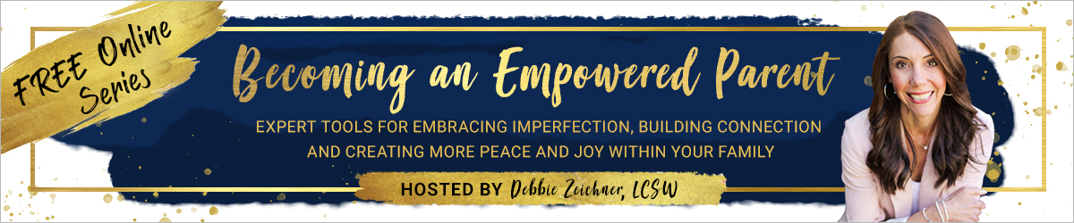
A Special Invitation to a FREE Online Series of Parenting Interviews with Leading Experts
Dear (Name),
If you ever struggle with the everyday challenges of raising your kids, find yourself caught in frequent power struggles, wish your kids would “just listen,” or experience feelings of guilt, shame, overwhelm or frustration, you are not alone!
Isn’t it amazing that the most important job in the world doesn’t come with an instruction manual?
My friend/colleague and Parent Coach, Debbie Zeichner, is on a mission to change this. The best part? It’s completely FREE!
Debbie has put together a powerful online interview series, Becoming an Empowered Parent: Expert Tools for Embracing Imperfection, Building Connection and Creating More Peace and Joy Within Your Family. This amazing series features 29 of the world’s leading parenting experts (including me!), who are sharing their top, research-based tools, strategies, insights and resources to support you in raising kind, compassionate, confident, emotionally healthy kids and teens who THRIVE!
Think of it as having a coffee date with some of the greatest minds in our modern parenting world, all offering insights and strategies for how to parent with purpose, presence and intention and show up as the empowered parent you are meant to be!
Don’t miss out on this INCREDIBLE opportunity to learn from the brightest minds and top-rated experts in the parenting field. All interviews are pre-recorded, so you can watch or listen at your convenience.
Learn more and grab your FREE spot by clicking this link >> your affiliate link >>
Bonus: Many of the experts will be offering a FREE GIFT, which you will definitely want to take advantage of AND Debbie has put together a FREE DOWNLOADABLE JOURNAL to go along with the event!
This is your opportunity to access this free, life-changing parenting series, which is only available for a limited time. Visit [your affiliate link] to get access now!
Your sign off

